**Software Application: SHAREIT**

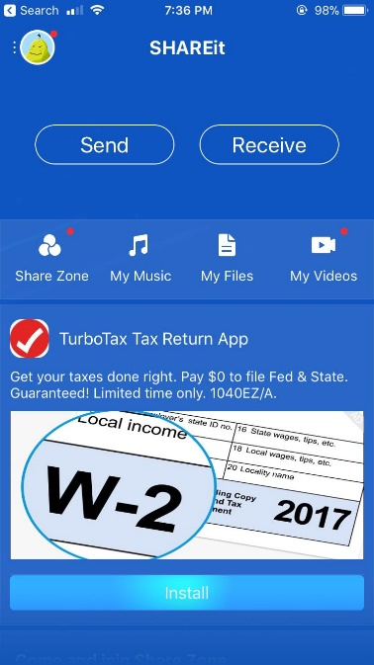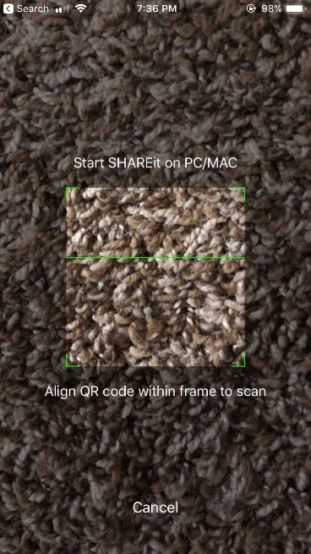

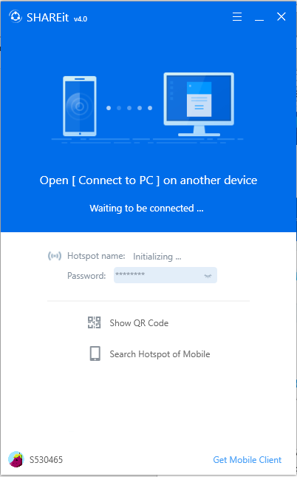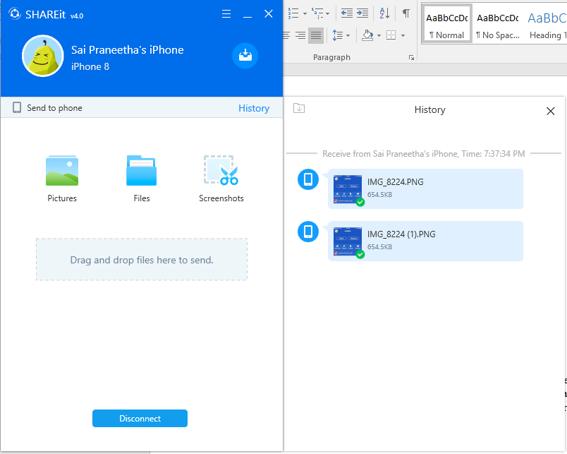

**DESCRIPTION:**

SHAREit lets you transfer files from different devices like phones, tablets, and computers. Using direct Wi-Fi connections, SHAREit can send files, photos, videos, and apps from one device to another. It can share almost all media, files. It is the most feasible platform one could use to share data. It is available online for different OS.

**AFFORDANCES:**

* + The software transfers data from one device to another. After downloading this software on both the devices, one has to choose to either send or receive data and choose the option accordingly. A sender sends the data while the receiver receives it. It has a blue color squared logo with a radial circle.
  + Both sender and receiver need to be on the same network for the data transfer to happen.

**SIGNIFIERS:**

* + When the software launches, it has two options to select to whether send or receive. It also has the menu that specifies history, vault etc.
  + The sender has to send the data from the device from the required category of data, media, documents, contacts etc.
  + You can also transfer from a phone to laptop by scanning the QR Code of the PC.
  + While transferring the data, you can see the percentage of the data transferred and the estimated time to be transfer. With the help of a blue horizontal line that fills itself, we can see the percentage of data that is remaining from a phone to another phone.
  + While transferring to a PC, a small green color tick is evident near the received file.

**MAPPINGS:**

* + Each button maps to a different control. Send is for a sender and receiver is for a receiver.
  + You can access all the received files from a folder Received files folder as specified in the menu.
  + The mappings are straightforward and are one beside the other.

**CONSTRAINTS:**

* + The app can function correctly when both the devices are on the same Wi-Fi networks. The mobile devices are required to switch on the hotspot for this purpose.
  + We have to re-open for each new connections.
  + It cannot store the paired device as in case of Bluetooth, the paired devices are listed.
  + We have different versions for different OS. It downloads after checking the OS requirements.

**CONCEPTUAL MODEL:**

* + The software is available online and is a freeware, which publishes its source code to the users.
  + It is a free, open source and multi-platform source. It allows you to transfer data from mobile to PC and vice-versa.
  + It has a section for FAQ where all the frequently raised doubts have answers.

**DISCOVERABILITY:**

* + The controls on pressing do their intended actions, which allows the user to form a mental model of the software.
  + While the software is in use, we can continue the usage of the device. The transfer will continue and the software minimizes itself.
  + The level of discoverability is high in this software as each click on the control is going to forward the reaction by either sending or receiving data.

**FEEDBACK:**

* + The logo depicts a cycle that shows three lines connected with three dots that do not clearly state that it is for data transfer.
  + The name itself depicts that it is used for sharing.
  + The feedback to the user that the data transfers while the blue bar fills itself and the percentage above it reach to 100%. This says that the selected data is completely transferred.

**GULF OF EXECUTION:**

* + Plan: To share files from one platform to another platform. It need not be the same platform.
  + Specify: Double click on the logo to get started with it.
  + Perform: Select the files and choose the receiver in the same network to send the files.

**GULF OF EVALUATION:**

* + Perceive: The files start transferring from one device from one to another with the percentage showing how much of the data is transferred and how much is remaining.
  + Interpret: We can verify the received files in the received files folder.

**Mechanical Device: BICYCLE**

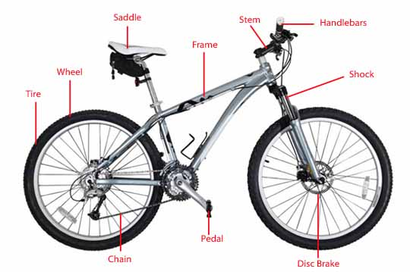

A bicycle often called a bike or cycle, is a human-powered, pedal-driven, single-track vehicle, having two wheels attached to a frame, one behind the other. Bicycles were introduced in the 19th century in Europe and as of 2003, more than 1 billion have been produced worldwide, twice as many as the number of automobiles that have been produced. The bicycle is an environmentally friendly and affordable vehicle. They are the principal transportation in many regions varying from metropolitan cities to hill topographic places.

**AFFORDANCES:**

* The bicycle primarily affords the user to drive from one place to another place and reach the destination.

**SIGNIFIERS:**

* The horn symbol on the handlebars is a signifier, which is used to the horn.
* The number of gears varies from one bicycle to other, which is indicated by numbers on the handlebar.
* The bottle symbol on the frame indicates water bottle carrier.

**MAPPING:**

* The handlebar, which controls the cycle direction.
* The control of the brake and gears that are to the left and right of the handlebar comes under cultural mapping.

**CONSTRAINTS:**

* The main constraint of the bicycle is the energy of the human who is riding it
* Road terrain is also one of the constraints
* We can accommodate a maximum of two people and limited weight.

**CONCEPTUAL MODEL:**

* The conceptual model is the model of information use that is independent of implementation details. It is prototype from which we can understand how to use a bicycle
* Above mentioned affordance, signifiers, mapping, and constraints help us in understanding the usage of bicycle

**DISCOVERABILITY:**

* The bike seat tells one that the bicycle is mean to be seated.
* The handlebars let a person know that his or her hands rest there and the ability to steer it implies how to move the bicycle to the left or to the right.
* The pedals indicate that while sitting on the bicycle, the feet rest on the pedals.
* The wheels indicate the object itself can move forward and backward.

**FEEDBACK:**

* The horn sound when we click the horn button is the feedback.
* If we apply the brakes, the cycle stops instantly provided with the feedback.

**GULF OF EXECUTION:**

* The user intention is to reach the destination by riding the bicycle; the person should get on the seat of the cycle and ride using the pedals.

**GULF OF EVALUATION:**

* The user from seeing the bicycle should identify how to ride using the pedals, handlebars, and gears.
* The personal goal is to ride the bicycle using the handle to control and directions, gears and break to control the speed.
* The comparison between these both is Gulf of Evaluation.

**Electronic Device: Washing Machine**

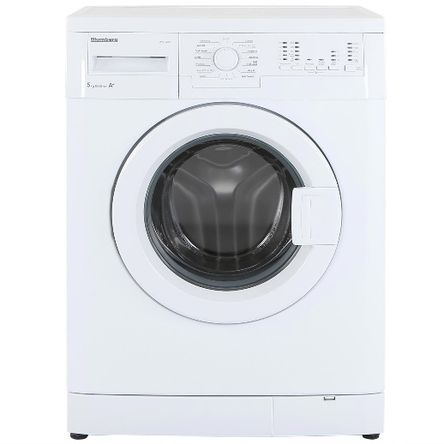

**DESCRIPTION:**

The interface of the washing machine is very simple so it is easy to find the correct buttons and select the type of wash cycle that is needed. There are no cumbersome buttons like on a stereotypical washing machine (hot-hot, hot-cold, cold-cold, etc.). By making the interface simplistic, it allows the users (college students) to easily use the machines.

**AFFORDANCE:**

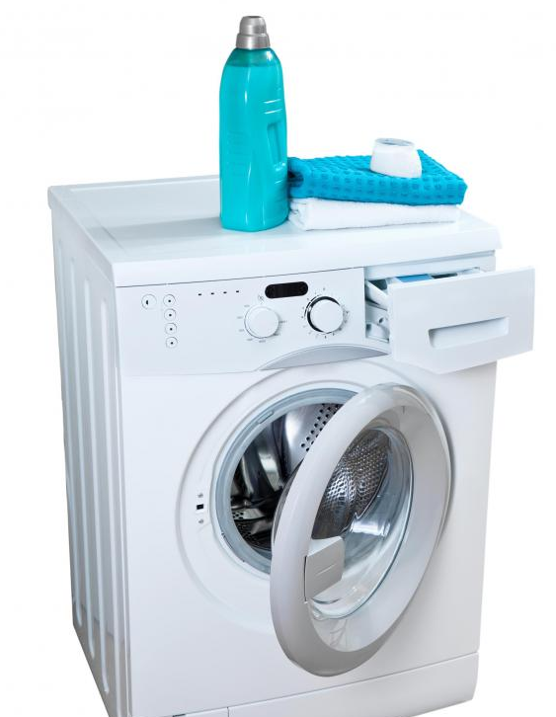

It is used for washing clothes that are dirty or have not been washed for a while. It provides the option to separate laundry by "color" and sort your clothes by fabric weight. It also puts delicate into mesh wash bags and gives the right option to choose the washing cycle to wash them gently. It provides us with setting pouring in detergent, the water temperature and other boosters like fabric softener. Finally, Load washer with clothes, Turn on the washer and unload clothes after they have been washed.

**SIGNIFIERS:**

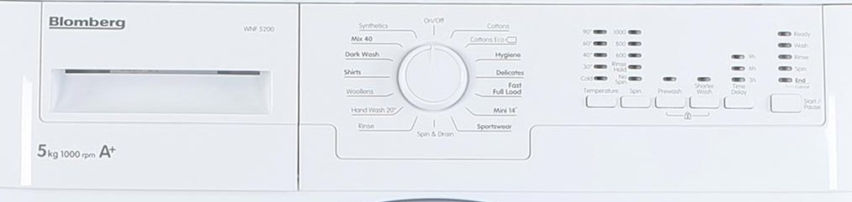

There are many signifiers all over the washing machine that help the user understand how to efficiently washing machine can be used. To select a wash cycle, the user can choose from whites, bright, colors. They can also choose from fabric settings such as perm press, woolens, and delicate/knits. Users can also choose for the temperature of water and quantity of detergent settings.

**MAPPING:**

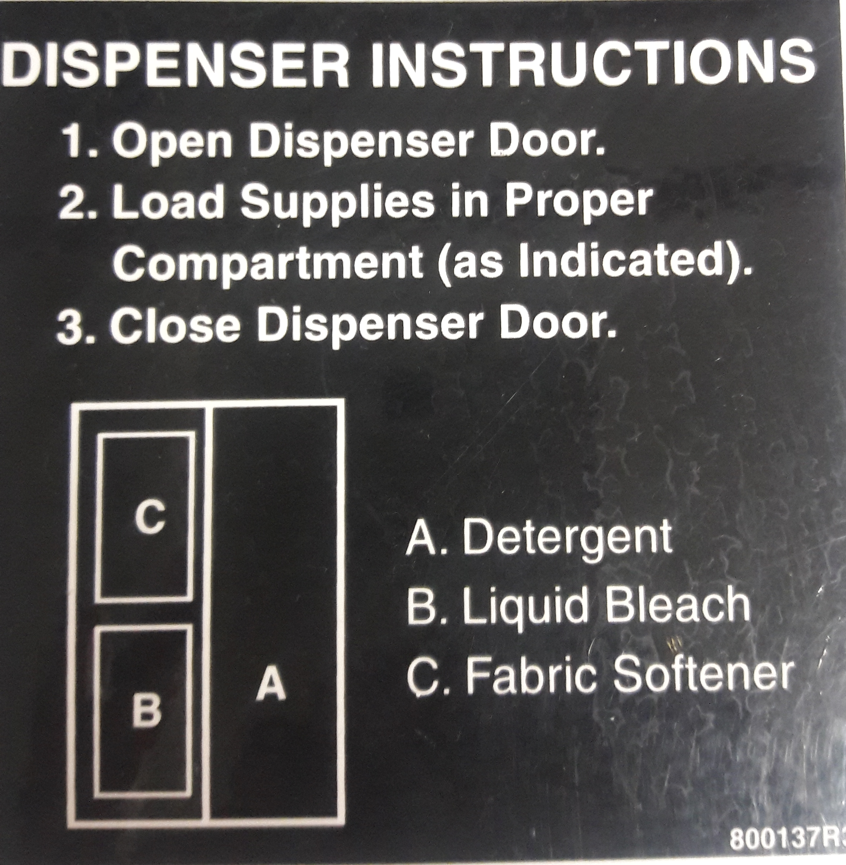 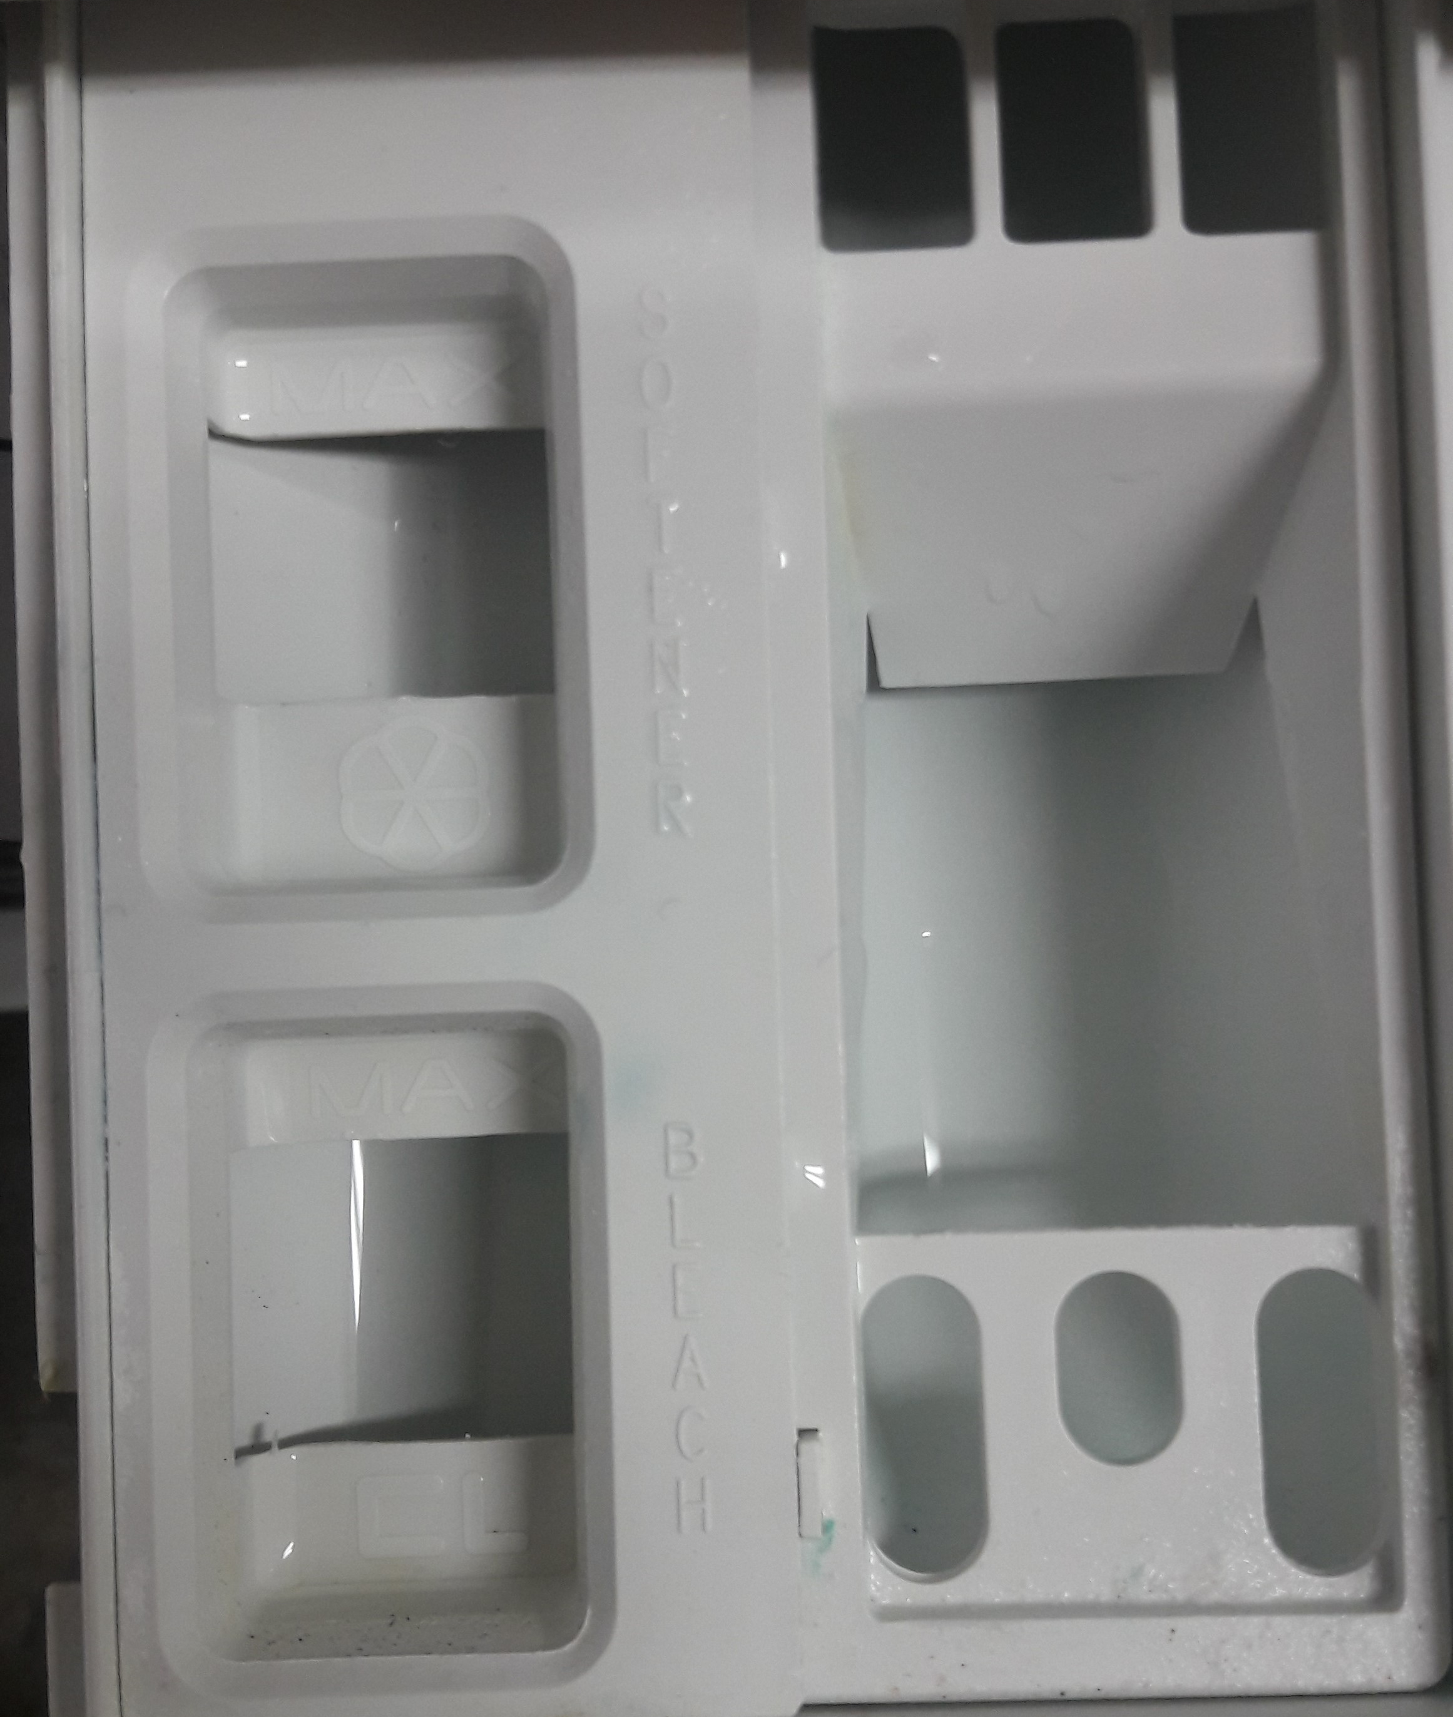

Based on the labels which are present on the washing machine, the process of mapping takes place. The label shows the options A, B and C and also specifies the type of dispenser to be used according to the options & diagrammatic symbol. Where at option “A” the user must use detergent, Liquid Bleach at “B” and Fabric Softener for “C”.

**DISCOVERABILITY:**

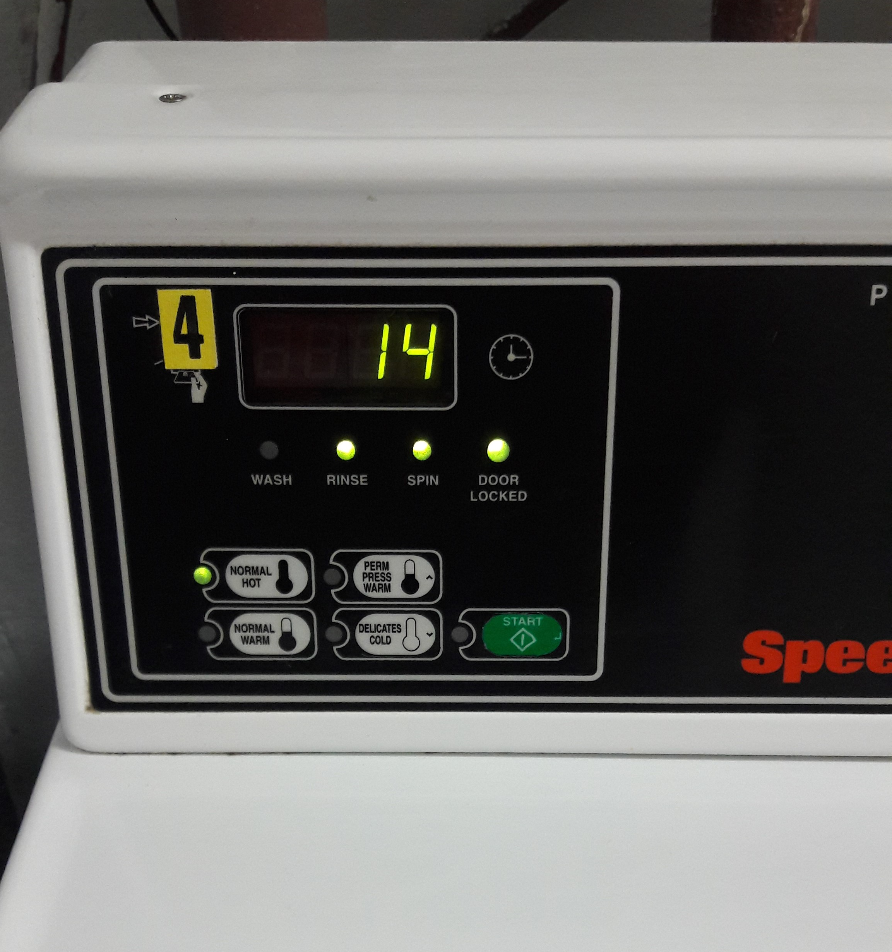

The discoverability specifies the numerous actions that are possible with washing machine and the current state. The above picture shows the current state of the washer by the different options provided. The current state of the washing machine is in the rinse, and it has been spun, getting ready to be washed and we can also see that the “door locked” option is “on”, which indicates that the machine is running and the timer indicates that there “14” more minutes are left for the washing machine to rinse the clothes.

**FEEDBACK:**

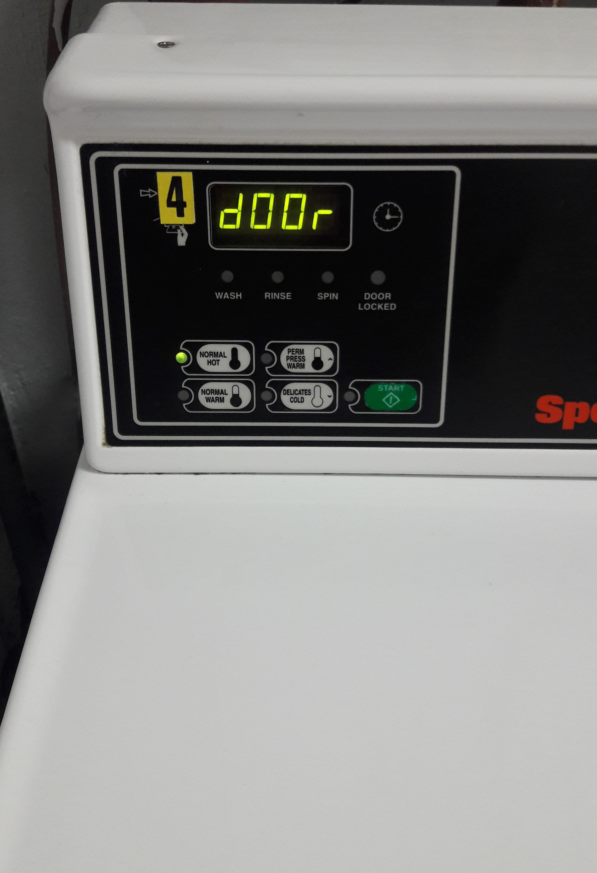 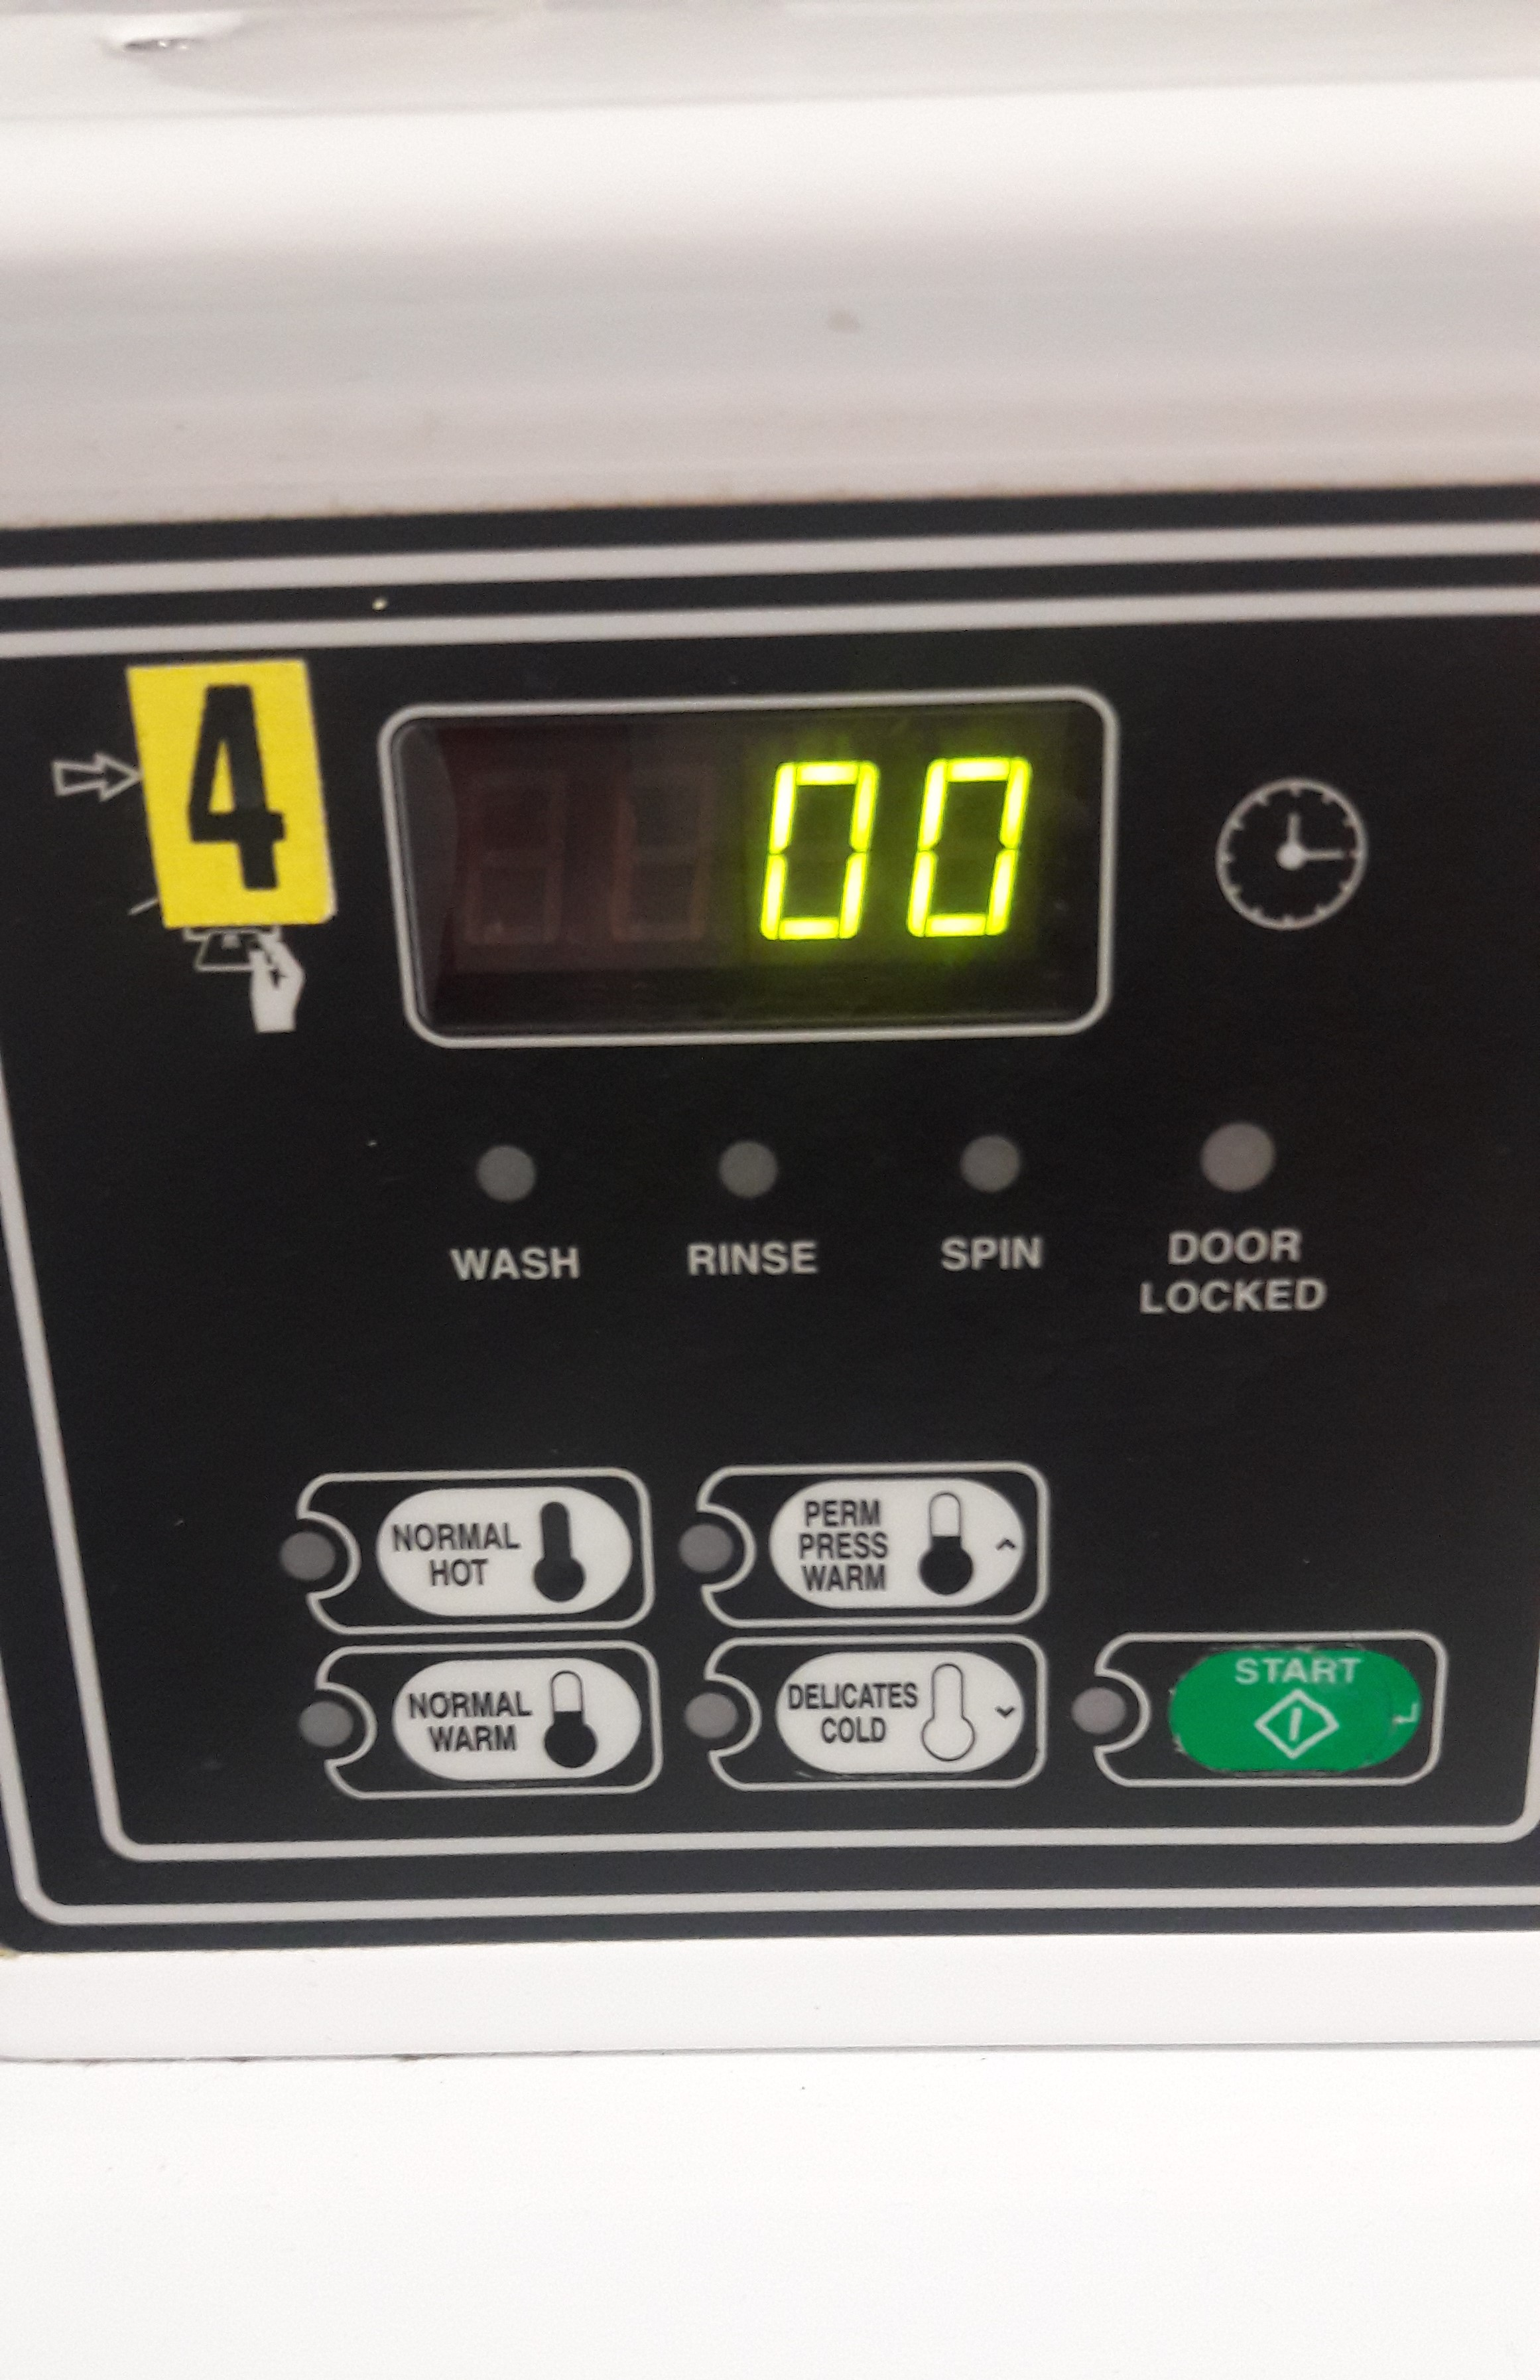

The feedback of a washing machine is quick and responsive. It produces a beep sound as soon as it is done washing the clothes; the timer also comes back to “00”. In addition, the washing machine door gets unlocked as soon as the clothes are washed and indicates us to open the door.

**CONSTRAINTS:**

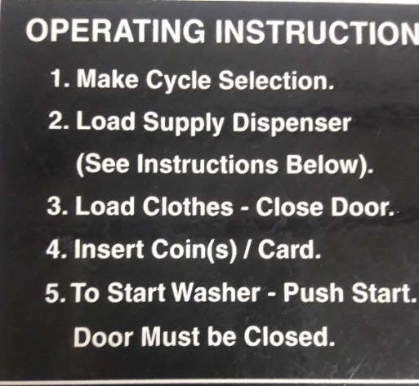

We have the instructions that guide the user to execute appropriate steps when using a washing machine. Following the steps by making cycle selection, loading the detergent, clothes and inserting the coin/card to practically starting the machine. These steps help ease the interpretation.

**GULF OF EXECUTION:**

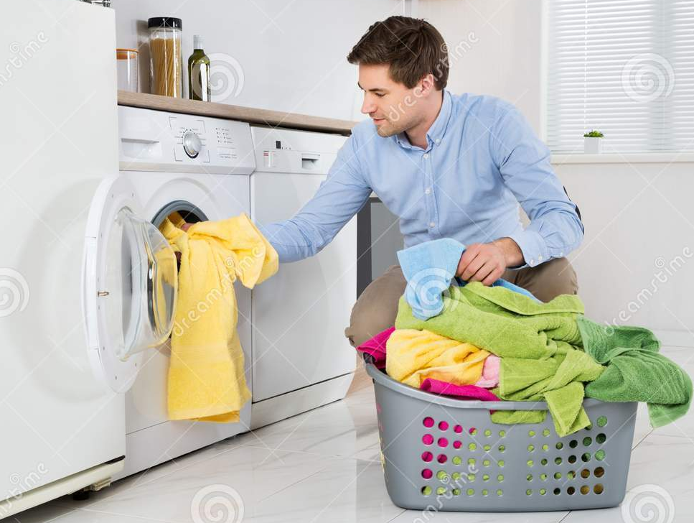

The first step in the Execution would be opening the washing machine door, then make the cycle selection. After that load the supply dispenser/detergent to rinse the clothes based on the signifiers. Then open door, load clothes and close the door. Insert coin/card. Then, we can choose different types of temperature settings needed to rinse, wash and spin the clothes and then push the start button of the washing machine to start washing the clothes. The door must be closed for the washing machine to start and operate. These are the allowable options in the Gulf of Execution stage.

**GULF OF EVALUATION:**

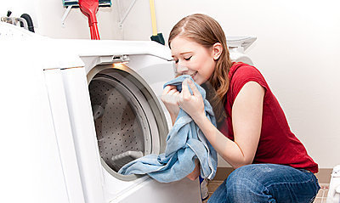

After the steps of spin, rinse and wash has been completed, the washing machine comes to a halt and door gets unlocked. Then the user can collect his clothes that are wet and check the expectations if whether the stains from the clothes have been removed and if the clothes smell fresh.

**Conceptual Model:**

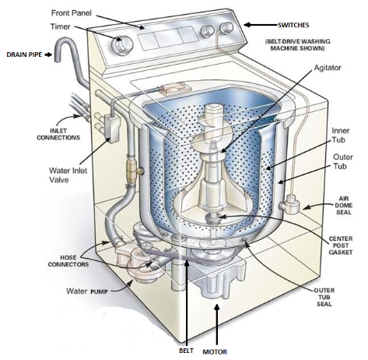

All the important parts of the washing machine are electrically controlled, including the inner drum, the valves, the pump, and the heating element. The machine programmer is like the conductor of an orchestra, switching these things on and off in a sensible sequence that goes on like the following steps:

* + You put your clothes in the machine and detergent either in the machine itself or in a tray up above.
  + You set the program you want and switch on the power.
  + The machine programmer opens the water valves so hot and cold water enters the machine and fill up the outer and inner drums. The water usually enters at the top and trickles down through the detergent tray, washing any soap there into the machine.
  + The machine programmer switches off the water valves.
  + The thermostat measures the temperature of the incoming water. If it is too cold, the machine programmer switches on the heating element. This works just like an electric kettle or water boiler.
  + When the water is hot, enough, the machine programmer makes, the inner drum rotate back and forth, sloshing the clothes through the soapy water. The detergent pulls the dirt from your clothes and traps it in the water.
  + The machine programmer opens a valve so the water drains from both drums. Then it switches on the pump to help empty the water away.
  + The machine programmer opens the water valves again so clean water enters the drums.
  + The machine programmer makes the inner drum rotate back and forth so the clean water rinses the clothes. It empties both drums and repeats this process several times to get rid of all the soap.
  + When the clothes are rinsed, the machine programmer makes the inner drum rotate at high speed—around 80 mph (130 km/h). The clothes are flung against the outside edge of the inner drum, but the water they contain is small enough to pass through the drum's tiny holes into the outer drum. Spinning gets, your clothes dry using the same idea as a centrifuge.
  + The pump removes any remaining water from the outer drum and the wash cycle ends.